TRUTH AND RECONCILIATION COMMISSION OF LIBERIA
PUBLIC HEARINGS IN THE U.S.
CONFRONTING OUR DIFFICULT PAST FOR A BETTER FUTURE:
THE DIASPORA EXPERIENCE
JUNE 9-14, 2008
Contents

- TRC Hearings Press Release …………………………………………………….…...1
- TRC Hearings Schedule …………………………………………….………………...4
- About Liberia ………………………………………………………………………....7
- About the Advocates for Human Rights ……………….…………………….……….8
- Timeline of the Diaspora Project ………………………………….………….....……9
- Commissioners of the Liberia TRC …………………………………………………12
- Logistics and Guidelines for Journalists …………………………………………….18
- Map of Facilities …………………………………………………………………….22
- Code of Conduct ……………………………………………………...……………..23
- Photographs …………………………………………………………………………25
- Past Articles ……………………………………………………………...………….30

Media Contacts: Michael Tankenoff
michael@jaustingroup.com
Laney Austin
laney@jaustingroup.com
Laura Waldman
laura@jaustingroup.com

(612) 354-2013

FOR IMMEDIATE RELEASE June 5, 2008

Liberian Truth and Reconciliation Commission HEARINGS TO BE HELD NEXT WEEK IN ST. PAUL, MINNESOTA
First TRC Hearings Ever Held in United States Will Focus on the Diaspora Experience

ST. PAUL – (June 5) – From 1979 to 2003, more than [NUMBER] Liberians were forced from their homes and their country to escape from the violence and destruction of a protracted civil war. Tens of thousands of Liberians eventually made their way to the United States in their flight from war, including some 30,000 who settled in Minnesota. Many of their stories have never been told.

Next week, the Liberian Truth and Reconciliation Commission (TRC), the body charged by the Liberian government with determining the facts of the human rights violations that occurred during the civil war, will meet in St. Paul, Minnesota, marking the first time any nation has ever conducted such hearings in the United States. The hearings are scheduled to begin on Monday, June 9th with public sessions set for June 10th through June 14th and will focus on the experience of Liberians in Diaspora. All nine members of the TRC are expected to attend the hearings.

“To fulfill our charter and our mission, we need to hear the stories of our citizens who fled their homes and ultimately their country,” said Counsellor Jerome J. Verdier, Sr, chairman of the Liberian TRC. “Many, many thousand Liberians suffered terrible violence and then suffered again through long and arduous travels and then suffered a third time as they arrived in new communities with little more than the clothes on their backs. Their experience is a part of what happened to our country at war with itself; understanding and sharing those experiences is an important part of our healing.”

This historic event will take place at Hamline University’s Sundin Music Hall at 1536 Hewitt Avenue, Saint Paul, MN. Commission hearings will begin at 9:30 a.m. (Central) each day and will conclude each afternoon at approximately 5:00 pm. The Liberian TRC is being assisted in the conduct of the hearing by its U.S. implementing partner, The Advocates for Human Rights.

Background on Liberia
Liberia is recovering from years of conflict that was the backdrop for horrific human rights violations, including arbitrary killing, use of child combatants, rape and sexual violence, separation of families, and looting and destruction of property. Out of a population of 3 million, an estimated 250,000 Liberians were killed, with as many as 1.5 million displaced. Of those forced to flee this violent conflict, many came to the U.S. because of the strong historical ties between the two countries.

The Liberian TRC was agreed upon in the August 2003 peace agreement and created by the TRC Act of 2005. The TRC was established to “promote national peace, security, unity and reconciliation,” and at the same time make it possible to hold perpetrators accountable for gross human rights violations and violations of international humanitarian law that occurred in Liberia between January 1979 and October 2003.

The U.S. hearings will also provide an important the opportunity for Liberians in the Diaspora to present their experiences and recommendations directly to the TRC, which is mandated to make binding recommendations to the government of Liberia. Each day, the commission will receive testimony from Liberian citizens who are part of the Diaspora experience. The testimony will focus on their experiences in Liberia during the civil war, in flight, in refugee camps and as they established new lives in new communities in the United States.

When and Where
Dates: June 9-14, 2008
Location: Sundin Music Hall, Hamline University, 1536 Hewitt Avenue, Saint Paul, MN

NOTE: No cameras or recording devices will be allowed in Sundin Music Hall, but all public sessions will be recorded in their entirety using a four-camera, live-switched audio and video capture system. Audio and video multbox, as well as a live pool feed, will be provided. The hearings also will be streamed live at www.trcofliberia.org.

For Further Information
Visit: http://liberiatrc.mnadvocates.org/Public_Hearings.html
Or contact:
Jennifer Prestholdt
Deputy Director, The Advocates for Human Rights
612-341-3302 ext. 111
jprestholdt@advrights.org

About The Advocates For Human Rights
The mission of The Advocates for Human Rights is to implement international human rights standards to promote civil society and reinforce the rule of law. The Advocates for Human Rights was founded in 1983 by a group of Minnesota lawyers who recognized the community’s unique spirit of social justice as an opportunity to promote and protect human rights in the United States and around the world. The organization has produced more than 50 reports documenting human rights practices in more than 25 countries; educated over 10,000 students and community members on human rights issues; provided legal representation and assistance to over 3,000 disadvantaged individuals and families and works with partners overseas and in the United States to restore and protect human rights.

About the Liberia TRC Diaspora Project
At the request of the Liberian Truth & Reconciliation Commission (TRC), The Advocates is coordinating the work of the TRC in the diaspora. Since Januray 2007, The Advocates has been collecting statements from Liberian refugees in the United States, the United Kingdom, and Buduburam Refugee Settlement in Ghana. The Advocates does not receive any funding from the TRC, but rather trains and supports more than 600 volunteers to provide nearly $4 million annually in pro bono services to the TRC.

While more than 30 countries have implemented some form of truth and reconciliation after periods of conflict and gross human rights violations, our Liberian TRC Diaspora Project is a new model of transitional justice. This is the first TRC to make a concerted effort to solicit from Diaspora communities both their stories of what happened to them and their families and their recommendations for reconciliation and systematic change. This groundbreaking project gives Liberians in Diaspora a voice in the promotion of international justice and human rights as part of the truth, justice, accountability and reconciliation processes in Liberia.

Hearings Schedule

MONDAY, JUNE 9, 2008

Briefings for Commissioners

In Camera Hearings (not open to public)

TUESDAY, JUNE 10, 2008

9:30 am-12:30 pm Opening Ceremonies

Liberian National Anthem
US National Anthem

Speeches
Chairman Jerome Verdier
Advocates Executive Director Robin Phillips
Ambassador Minor (invited)
Senator Amy Klobuchar (invited)
Hamline University Vice President Dan Lauritz

Introduction to Liberian History (Dr. Augustine Konneh)

Cultural Performance by Ambassador Juli Endee (invited)

12:30-2:00 pm Break

1:00-1:30 pm Press Conference

2:00-5:00 pm Individual witness testimony
1979-1980: Rice Riots and Military Coup Against President Tolbert

WEDNESDAY, JUNE 11, 2008

9:30 am-12:30 pm Individual witness testimony
Finish 1979-1980 Tolbert administration witnesses; begin 1980-1990: People’s Redemption Council (PRC) and Civilian government under President Samuel K. Doe

12:30-2:00 pm Break

2:00-5:00 pm Individual witness testimony
1980-1990: People’s Redemption Council (PRC) and Civilian government under President Samuel K. Doe; early days of the NPFL insurgency

THURSDAY, JUNE 12, 2008

9:30 am-12:30 pm Individual witness testimony
1990-2003: Conflict and factional fighting; displacement and life in refugee camps

12:30-2:00 pm Break

2:00-5:00 pm Individual witness testimony
1990-2003: Conflict and factional fighting; displacement and life in refugee camps

5:00-6:00 pm Audience Discussion and Q&A with Commissioners

FRIDAY, JUNE 13, 2008

9:30 am-12:30 pm Individual witness testimony
1990-2003: Conflict and factional fighting; displacement and life in refugee camps

12:30-2:00 pm Break

2:00-5:00 pm Diaspora organization testimony
Experiences of the Liberian Diaspora

5:00-6:00 pm Audience Discussion and Q&A with Commissioners

SATURDAY, JUNE 14, 2008

9:30 am-12:30 pm Diaspora organization testimony

12:30-2:00 pm Break

1:00-1:30 pm Press Conference

2:00-3:30 pm Diaspora organization testimony

3:30-5:00 pm Town Hall Meeting with TRC and
Closing ceremonies

About Liberia
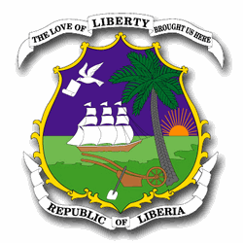

The Republic of Liberia
Founded July 26, 1847.

Geography
The Republic of Liberia is on the coast the Atlantic Ocean in Western Africa. It shares borders with Sierra Leone, Guinea, and Côte Ivoire. Liberia is in a tropical climate, and many parts of the country which are neither cultivated nor inhabited are tropical forest. In the first half of the twentieth century, this climate led the Firestone Rubber Company to establish large rubber-growing operations in Liberia. Monrovia is the capital and largest city.

Government Structure
The Government of Liberia has a similar constitution to that of the United States. There is a single executive, President Ellen Johnson-Sirleaf. She is in her first six year term. Like the United States President, she is served by a cabinet appointed by herself and confirmed by the Senate.
The Liberian Legislature is bi-cameral and popularly elected. Liberian Senators serve staggered terms, with only some incumbents on the ballot in each election.

Language and Religion
English is the official language of Liberia, but it is spoken in unique dialect. In addition to English, there are over twenty indigenous languages and dialects.
Liberia has several religious traditions. Christianity and Islam were imported in the last three hundred years. In addition to these, many Liberians also practice indigenous traditions, such as animism (the belief that spirits interact with the world) and prayer to ancestors. Some Liberians hold these traditions contemporaneously with a monotheistic tradition.

About The Advocates for Human Rights

The mission of The Advocates for Human Rights is to implement international human rights standards to promote civil society and reinforce the rule of law. The Advocates was founded in 1983 by a group of Minnesota lawyers who recognized the community’s unique spirit of social justice as an opportunity to promote and protect human rights here at home and worldwide. We are a non-profit, volunteer-based organization that investigates and exposes human rights violations; represents immigrants and refugees in our community who are victims of human rights abuses; trains and assists groups that protect human rights; and works through education and advocacy in Minnesota to engage the public, policy-makers and children about human rights and cultural understanding.

TRC Project Staff Contact Information

The Advocates Office: 612-341-3302

Robin Phillips Executive Director ext. 109
Jennifer Prestholdt Deputy Director ext. 111
Michele Garnett McKenzie Refugee & Immigrant Program Director ext. 117
Rosalyn Park Staff Attorney ext. 106
Ahmed Sirleaf Program Associate ext. 134
Laura Young Wellstone Legal Fellow ext. 128

The Advocates Website: www.theadvocatesforhumanrights.org

TRC Project Website: http://liberiatrc.mnadvocates.org

TRC Project E-Mail: Liberia-TRC@advrights.org

Liberia Truth & Reconciliation

Diaspora Project

Timeline

June 22, 2006 | Launch of TRC in the United States and Liberia  Concurrent ceremonies took place in Monrovia and at the Minnesota State Capitol in St. Paul. The Advocates begins outreach in the Liberian community.
July 2006 | Formation of the National Advisory Committee  Composed of prominent Liberians from Minnesota and the U.S., this group advises The Advocates in developing the project.
July 28, 2006 | Commencement of Volunteer Training  A consortium of 13 Twin Cities law firms stepped forward to provide volunteer and logistical support to the TRC’s work in the U.S. Volunteers are required to complete 9 hours of training to become statement takers.
September 28- October 15, 2006 | TRC Member Massa Washington Visits the U.S.  As the Commissioner with oversight over the Diaspora project, Washington conducted community outreach events in Minnesota, Washington, DC and Staten Island, NY.
November 2006 | TRC Chairman Cllr. Jerome J. Verdier, Sr. Visits the U.S.  Verdier met with the Project management team in Minnesota participated in a full-day Advisory Committee retreat and conducted community outreach in Minnesota and Providence, RI.
Nov.-Dec. 2006 | Pilot Testing of Statement Taking  Working with the National Advisory Committee, Minnesota Advocates took a small number of statements to test forms and protocol and get feedback from statement givers
Jan. 11, 2007 | Large Scale Statement-taking Begins in Minnesota  Statement taking in the Midwest will continue through May 2008
Feb. 4-5, 2007 | outreach begins in philadelphia  Executive Director Robin Phillips holds planning meetings with implementing partners in Philadelphia and members of the Liberian community.
Feb. 10-17, 2007 | The Advocates team travels to liberia  robertsport Accord (Memorandum of Understanding - MOU) signed between The Advocates and the TRC
Feb. 18, 2007 | Town Hall Forum with Liberian Community in Chicago  Co-sponsored by Northwestern Law School, the Organization of Liberians in Chicago, and The Advocates
Feb. 24, 2007 | TRC U.S. Statement Taking Project Kick-off Celebration!  Co-sponsored by the Organization of Liberians in Minnesota and Minnesota Advocates, the event featured Commissioner Massa Washington, Liberian Cultural Ambassador at Large Juli Endee, and TRC Executive Director Nathaniel Kwabo.
March 3, 2007 | Statement taking Begins in Chicago  As part of the Midwest project, a small number of statements are being taken by students from the Northwestern University Law School.
March 8-11, 2007 | Outreach begins in Atlanta  commissioner Washington and Executive Director Robin Phillips hold planning meetings with implementing partners in Atlanta. Commissioner Washington and Ambassador Juli Endee conduct outreach in the Liberian community.
March 22-April 1, 2007 | Outreach begins in Buduburam camp in Ghana  Commissioner Washington conducts planning and outreach for statement taking in the Diaspora community in Ghana.
May 4-5, 2007 | Statement Takers trained in Atlanta
May 13-19 | Pilot statement taking in buduburam camp, ghana  The Advocates team of 4 staff and volunteers join Commissioner Washington and 2 TRC staff to take more than 160 statements from Liberians in the refugee camp.
June 13-14, 2007 | Statement Takers trained in Philadelphia
June 16, 2007 | statement taking officially launched in philadelphia at town hall forum with chairman verdier
June 20, 2007 | forum on reconciliation, reparations and recommendations in minnesota
June 23, 2007 | Statement Taking Officially launched in Atlanta  Town Hall Forum with Chairman Verdier
July 2007 | trc outreach month in the u.s.
August 17-18, 2007 | second atlanta volunteer statement taker training

Late August 2007 | public engagement teleconferences with advisory committee members and statekholders on reconciliation strategies
September 9, 2007 | TRC workshop on staten island
September 14, 2007 | Organizational Meeting with Partners in Washington D.C.
September 19-20, 2007 | Volunteer statement taker training in Washington D.C.
September 19-20, 2007 | Volunteer statement taker training in London, U.K.
September 21- October 7, 2007 | Volunteer teams travel to Budumburam to take statements from Liberians in Ghana and coordinate with statement taking team at the camp
October 7, 2007 | Town Hall Meeting on the TRC in Trenton, NJ
October 11-12, 2007 | Volunteer statement taker training in New York, NY.
October 13, 2007 | Statement taking begins on Staten Island
November, 2007 | Chicago town hall meeting  commissioners Massa Washington and Oumu Sylla visited and held a community town hall meeting.
January 11, 2008 | Volunteers start training in Boston and Providence.
February 14, 2008 | Statement taking launched in Providence along with the Liberian Community Association of Providence, Rhode Island as well local implementing partners, The Advocates launched for TRC statement taking with a press conference.
February 20, 2008 | Manchester training takes place in manchester, U.K.
March 1, 2008 | community town hall meeting in oakland, ca
March 2, 2008 | community town hall meeting in Winston-salem, to discuss statement taking outreach program
June 10–14, 2008 | Public Hearings in the U.S.

Commissioners of the Liberia TRC

Cllr. Jerome J Verdier, Sr, Chairman
Cllr. Verdier was a leading human rights and civil society activist prior to his selection to serve on the TRC. He holds a Bachelors of Business Administration (BBA) Degree in Accounting and Economics(1988) from the University of Liberia and a Bachelors of Laws Degree (LLB) from its Louis Arthur Grimes School of Law. Apart from working both in the private and public sectors as Senior Accountant, Comptroller and Executive Director, he has been instrumental in strengthening civil society advocacy whilst serving in several capacities as Executive Director of Liberia Democracy Watch (LDW); Chairman of the Board of Directors of The National Human Rights Center of Liberia (NHRCL), a consortium of nine human rights and pro-democracy organizations; Board Chairperson of the Foundation For International Dignity (FIND); Senior Staff Attorney for the Association of Environmental Lawyers (Green Advocates); and the first Research & Program Officer of the Catholic Justice & Peace Commission (JPC). Cllr. Verdier is a practicing attorney, credited for rendering pro bono legal services to indigents, civil society activists and journalists, whilst also leading civil society adversarial legal teams in several successful lawsuits against the government of Liberia.

Dede Dolopei, Vice Chairperson
Commissioner Dede Dolopei is a Liberian administrator, manager, social worker and peace activist. She is a graduate of the University of Liberia, holding a BBA in Accounting with an emphasis in Management, and is currently a Msc. candidate in Regional Planning. She has served as a member of the Board of Directors for NAWOCOL and the Christian Foundation for Children and the Aging. Commissioner Dolopei has been instrumental to the promotion and protection of women rights in Liberia, and she is well known for her efforts and expertise in peace building, conflict resolution and psychosocial counseling.

Oumu K. Syllah, Treasurer
Commissioner Oumu K. Syllah is a trained registered nurse, HIV/AIDS counselor and social worker. She holds a Bachelor of Science degree in Nursing from Cuttington University College, Bong County, Liberia and a Certificate in Nursing as a State Registered Nurse (SRN) from the National School of Nursing in Freetown, Sierra Leone. Commissioner Syllah has worked as a professional nurse and social worker in renowned hospitals, including Cannaught Hospital in Freetown and St. Joseph Catholic Hospital in Monrovia. She has also acted as a Trainer/Facilitator and participant in numerous workshops in the field of social work.

Sheikh Kafumba F. Konneh, Member
Commissioner Konneh is a Liberian Muslim Authority who has a long record of conflict resolution and peace building efforts throughout the major civil and military conflicts in Liberia. In addition to his theological (Al-Islamic) achievement, the Sheikh studied secular law through apprenticeship. He held several positions in the civil service, including Justice of the Peace, Associate Stipendiary Magistrate and County Commissioner in Nimba County, his birthplace. He has also served as Secretary General and Managing Director of the Liberian Muslim Union, as well as Secretary General and National Chairman of the National Muslim Council of Liberia.

Cllr. Pearl Brown Bull, Member
Cllr. Pearl Brown Bull has been a lawyer and renowned Liberian politician since the late seventies. She has obtained numerous degrees, including a Bachelors of Arts (BA) in Political Science from the University of Liberia and a Juris of Law degree from the University of Quinnepec, USA, and has graduated from both the Montheith Travel School in Raleigh, NC, USA and International & Domestic Airline Training at American Airlines in Cary, NC, USA. Cllr. Bull also served as Professor of Management & Supervision in Law Enforcement and Criminal Evidence at Shaw University, USA. She has held a number of high profile public positions including Member of the Interim Legislative Assembly, Member of the Constitutional Advisory Assembly, Member of the Public Procurement and Concession Commission, Member of the Panel of Experts for the Selection of Commissioners of the Independent National Human Rights Commission of Liberia, and Country Vice President of the International Federation of Women Lawyers. She is a legal drafter with over a quarter of a century of experience in peace building, conflict resolution and social work.

Rev. Gerald B. Coleman, Member
Ambassador Coleman is an electrical engineer and project manager by training, having completed a Masters degree in Electrical Engineering (M.S.E.E.) and post graduate studies in Engineering Management at Northeastern University, USA?. Rev. Coleman is the Spiritual Elder and founding national missionary of the Unification Movement of Liberia and has worked with the mission over 25 years. In 1996, he was commissioned Ambassador and Special Envoy of the Government of Liberia to the Far East. During this period, he worked for the peaceful transition of LNTG III to civilian government by facilitating several peace-building, scholarship and cultural exchange programs for Liberian youth and food-aid programs between Asia & Liberia.
In 2000, Ambassador Coleman, along with several other prominent Liberians, launched the Inter-Religious & International Federation for World Peace of Liberia (IIFWP-Liberia) as a national branch of an international Peace-Building NGO. The NTGL asked Amb. Coleman to help facilitate the establishment of the current TRC, a process which culminated in the final passage of the TRC Act of Liberia in June 2005.

Commissioner John H. T. Stewart, Member
John Stewart is a Liberian journalist, rights advocate and activist in Liberia. He was educated at the University of Liberia and has held numerous positions including Local Consultant for the Media Foundation for West Africa; Reporter for Channel Africa; Regional Coordinator for the Catholic Justice and Peace Commission; Information Assistant for the United Nations Population Fund (UNFPA) and National Assistant Field Security Advisor to the United Nations Development Program. Commissioner Stewart s advocacy efforts have included work with the Citizens of Liberia Against Gambling (COLAG), Citizens of Liberia in Defense of Albert Porte, (COLIDAP), and the Movement for Justice in Africa (MOJA). He has been an advocate for the past 30 years, a time period spanning the administrations of Presidents William R. Tolbert, Samuel K. Doe, and Charles Taylor, and he has suffered imprisonment as well as physical and mental torture as a result of his efforts. As a journalist, he is well known for his acerbic writing and interviewing style, having served as Associate Editor of the New Democrat Weekly and presenter of the Radio Veritas Topical Issues program.

Commissioner Massa Washington, Member
Massa A. Washington is a journalist with more than twenty years of experience. She holds a B.A. in Mass Communication with emphasis in Print Journalism from the University of Liberia and is currently a second-year graduate student with high honors at the Temple University School of Social Administration and Management, Pennslyvania, USA. She also obtained training in Broadcast Journalism from the Voice of America (VOA) and the Liberian Broadcasting System (LBS) in 1984. Her past positions have included Public Relations Officer of the Liberian National Red Cross Society, Senior Reporter for the Ministry of Information New Liberian Newspaper, and News Editor for the Independent Inquirer. Ms. Washington has covered the Liberian crises extensively, reporting often from occupied territories and creating a
column in the Inquirer dedicated to Liberian women. She is a women's rights and civil society activicts and is a member of the Liberian Women Initative (LWI) which has been at the vanguard of peace advocacy in Liberia. She has also represented the women of Liberia at peace conferences, such as both of the Accra Clarification Conferences and the Abuja Conference. Ms. Washington has also worked with Liberians in the Diaspora, having represented and given sworn testimonies for Liberians seeking legal status in the USA. She served as Chairman of the
Association of Liberian Journalist in the Americas (ALJA), Deleware Valley Chapter, representing the States of Pennslyvania, Deleware, and New Jersey in the U. S. A., and co-owed and published the Iwina Heritage Newspaper targeting the African immigrant community in the United States. Ms. Washington has received honors including; Press Union Reporter of the Year
Award, Inquirer Reporter of the Year Award 1994, The Association of Liberian Journalist in the Americas Appreciated Award in 2003, Liberian Community Association of Pennsylvania Award in 2003 and Special Recognition for distinquished leadership by the City of Philadelphia Welcoming Center for New Immigrants in 2004. Ms. Washington is also one of sixteen Liberian peace activists featured in a recent UN Peace Building Book.

Media and Press Guidelines

Welcome and thank you for attending the Liberian Truth and Reconciliation Commission Hearings at Hamline University. Your presence is an important part of our process and essential to completing the work of the Commission.

To help you cover this important event, we have established the following guidelines for the media. We ask that you abide by these guidelines at all times as well as requests for the hearing staff.

Registration and Credentials

All media covering the hearings must be registered and wear their credentials at all times. The media registration table is located in the entrance to the Drew Fine Arts Center (see map). Credentials are good for all days of the hearing. Registration times are between 8:30 am and 5:00 pm each day.

Media Assistance

Volunteers are available to assist members of the media covering this event. Check at the media registration table in the entrance to the Drew Fine Arts Center.

Code of Conduct

Liberian journalists, in coordination with the Liberian Truth and Reconciliation Commission, have created a code of conduct for covering the Commission’s proceedings. A copy of this code of conduct is attached and journalists attending the hearings are asked to abide by its principles.

Covering the Hearings

A schedule of each day’s hearing is included in your registration packet. Hearings will begin each day at 9:30 am and end approximately 5:00 pm with breaks scheduled throughout the day. Any schedule changes will be available at the media registration table in the entrance to the Drew Fine Arts Center.

The media is welcome to directly observe the proceedings of the Commission, which will take place in Sundin Music Hall, and seats have been reserved for this purpose. Enter the hall through the public entrance and show your credentials to the volunteers who will direct you to the designated seating. Seating is available on a first-come, first-serve basis and seats cannot be reserved or held. The hearing room will be cleared during all lunch breaks and other lengthy recesses.

Please note, however, that no cameras, laptops or recording devices will be allowed in Sundin Music Hall. All audience members, including media, will be required to check all bags, backpacks, purses and other objects before entering the hall. The bag check facility will be staffed continuously.

Media also may observe the proceedings of the Commission via a live remote video and audio feed available in the Anne Simley Theatre located in the Drew Fine Arts Center. This space, which is open to the public as well as “overflow” seating, has a number of seats set aside for the media with workspace and power provided. Seating is available on a first-come, first-serve basis and seats cannot be reserved or held. The Anne Simley Theatre will be accessible between the hours of 9:00 am and 6:00 pm daily.

In addition, all public sessions will be recorded in their entirety using a four-camera, live-switched audio and video capture system. Audio and video “multbox” as well as a live pool feed will be provided and accessible from the Anne Simley Theatre. Volunteers will be on-hand to facilitate use of these media.

The hearings also will be streamed live at www.trcofliberia.org.

Additional work space has been set aside in Room 208 of the Klas Center adjacent to the Drew Fine Arts Center. See the attached map for the location of this space.

Interview Requests

To respect the privacy of the witnesses and to permit the Commission to conduct its work as efficiently as possible, all requests for interviews should be made to the media volunteers who will convey the requests to the Commission staff and to the witnesses. Every effort will be made to accommodate all media requests consistent with the wishes of the witnesses and the work of the Commission. Interview space is available for the media on request. Media volunteers will staff interviews to assist the Commission and its witnesses.

Media volunteers can be contacted at the media registration table in the entrance to the Drew Fine Arts Center.

In addition, it is anticipated that members of the Commission will be available to the media at the conclusion of each day’s schedule to address the hearings just concluded or to look ahead to the next day’s schedule. These question-and-answer sessions are subject to availability and their timing and location will be determined each day.

Safety and Security

The hearings will be staffed with uniformed security personnel and we ask that you follow their direction. The media is not permitted in certain areas of the facilities that have been designated for the exclusive use of the Commission and/or its witnesses. Any behavior that is disruptive to the proceedings is grounds for revocation of media credentials and exclusion from the Commission’s proceedings.

The Commission, its organizers and volunteers are not responsible for any lost or stolen possessions; you are encouraged not to leave personal possessions or equipment unattended. Equipment and other materials may not be stored or left in place overnight.

Media Contacts

The media registration table should be staffed throughout the proceedings and media volunteers should be circulating throughout the proceedings. Should a member of the press need assistance, please visit the media registration table in the entrance to the Drew Fine Arts Center or contact one of the following individuals:

Jon Austin
612-839-5172
jon@jaustingroup.com

Laney Austin
612-384-4449
laney@jaustingroup.com

Michael Tankenoff
952-334-2582
michael@jaustingroup.com

Laura Waldman
952-212-3349
laura@jaustingroup.com

Internet Access

Hamline University has provided access to its guest Wi-Fi system for the convenience of the Commission and its witnesses and guests. Please follow the instructions below to access the network.

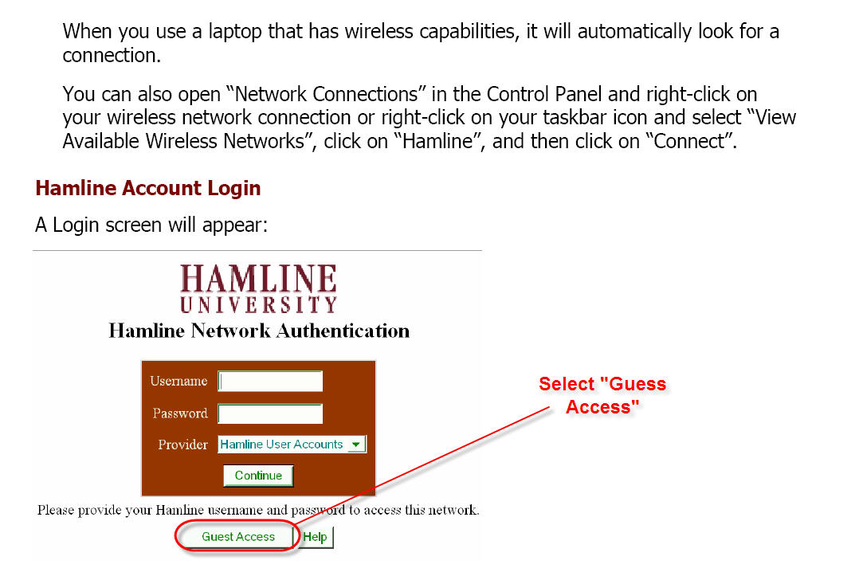
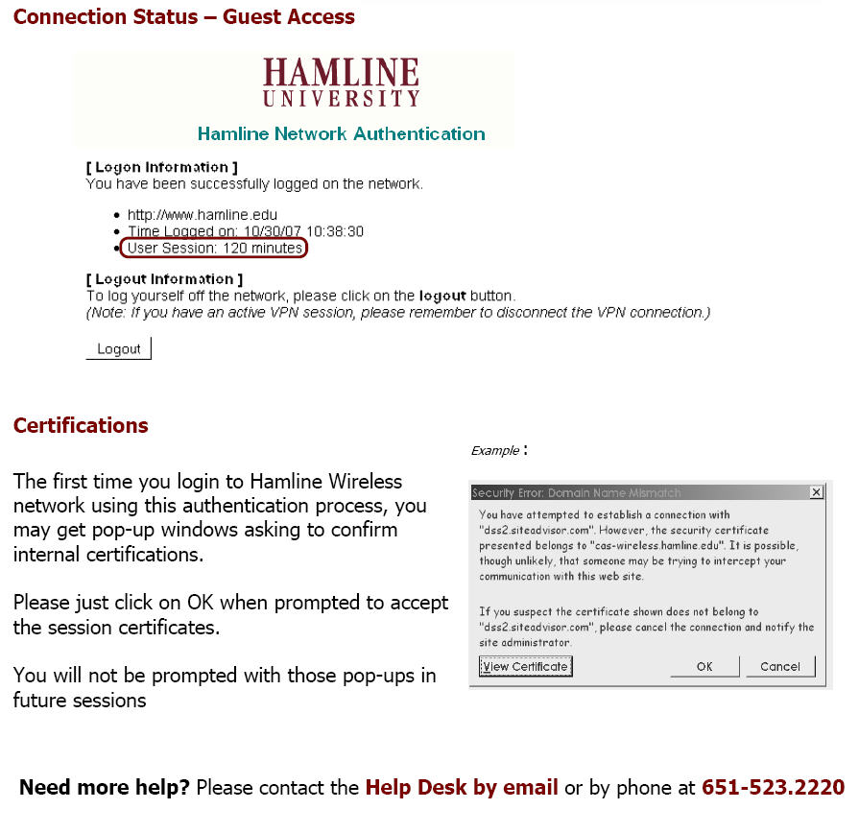
Map of Hamline Facilities

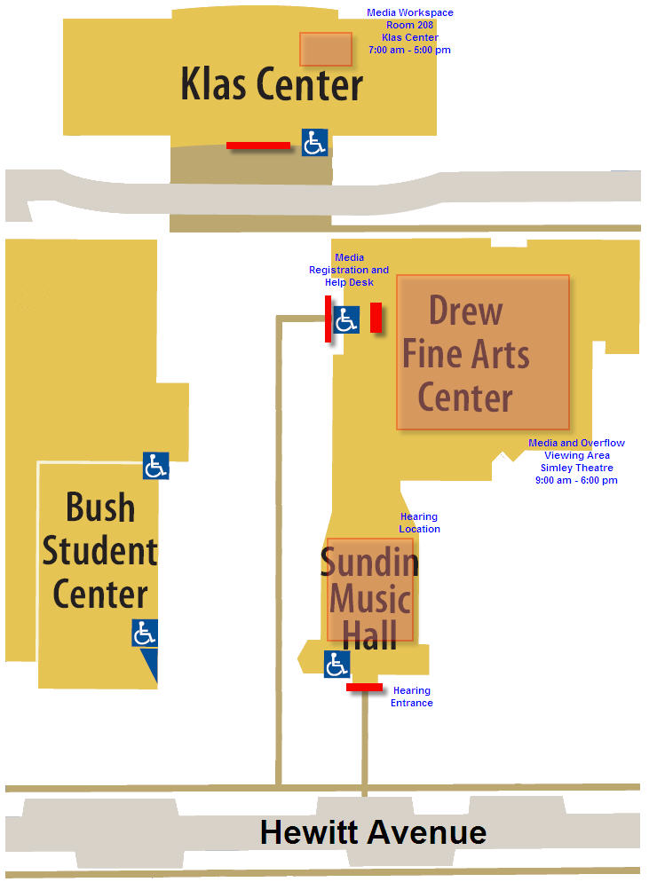

CODE OF CONDUCT FOR JOURNALISTS COVERING THE LIBERIA TRC

This document was created by Liberian journalists in cooperation with the Liberia TRC. While the TRC Diaspora Project cannot hold journalists in the United States to this standard, we ask for your respect and cooperation in covering the Diaspora Project based on these guidelines.

Our duty to provide information as Journalists is premised on the assumption that society needs information to progress. We work for the progress of society. Our actions should be guided by principles that advance the common good of society. For us in Liberia, that means promoting peace and national reconciliation.

The TRC was established “to promote peace, security, unity and reconciliation.” Supporting the TRC is therefore a national call as well as a professional duty.

The general principle underlying the Code of Ethics of the Press Union of Liberia shall be the guide for all journalists in their reportage of the TRC. Consequently, respect for the truth, accuracy, balance, the protection of individual dignity, and fairness shall be the cardinal principles in the coverage of the TRC.

We therefore agreed that:
- Journalists should ensure that what he/she reports is without distortions. The journalist should refrain from defamation, obscenity, slander and uninformed accusations.

- Journalists should respect the rights and dignity of all those involved with the TRC. Reporters should note that statements/testimonies given to the TRC in closed hearing are confidential unless otherwise indicated. The rules relating to the confidentiality of sources and evidence of witnesses as provided for in the Truth and Reconciliation Commission of Liberia shall also be observed

- Journalists are not allowed to interview witnesses while their appearance and testimony are pending before the TRC. Interviews can only be conducted after the person shall have appeared before and debriefed by the TRC.

- Journalists should exercise care and sensitivity in seeking, publishing and broadcasting information about people who are personally grieved and distressed.

- Malicious information liable to discredit a person or expose him/her to ridicule or hate should not be published/broadcast.

- Journalists who discover or are referred to information that may constitute evidence for prosecution should refrain from actions that could compromise the integrity of evidence and seek the participation of official institutions in the discovery. This applies specially to forensic evidence and archives.

- Journalists should refrain from publishing the identity of key witnesses to acts under the mandate of the commission or acts potentially subject to prosecution, if publication may endanger the witness’ security or integrity.

- Journalists should report accurately and avoid misleading and sensational headlines. Headlines should be fully warranted by the contents of the articles they accompany.

- Photographs should give an accurate picture of an event and not portray or sensationalize an incident out of context. The TRC should ensure that every person that appears in a public hearing should have been understood to the possibility of his or her picture being published.

- Journalists should ensure balance coverage of all sides of the conflict presented to the TRC with particular attention to the issues of tribal, religious, sectional and political implications.

- Journalists should draw a clear distinction between comments, conjecture, facts and testimonies.

- Journalists should avoid identifying victims of sexual assault. The journalists should also be aware of gender-based assumptions and prejudices and guard against stereotyping.

- Care and sensitivity shall be applied in the coverage of special vulnerable groups like women and children. The coverage of children in particular shall be guided by the UNICEF guidelines on reporting on children.

- The language of the press shall reflect the language of the TRC. The labels, attributes and references to persons as decided by the commission (e.g. witnesses, victims, perpetrators, etc) where possible shall be the language of the press. The press shall therefore treat all witnesses with respect and refrain from name calling and stereotyping.

- Journalists shall refrain from making exaggerated claims about the Commission in order to help manage public expectations of the commission.

- The relationship between the press and the Commission shall be guided by the principles of mutual respect and cooperation.

- Journalists shall respect the TRC as the master of its process and consequently refrain from interfering in the work of the Commission.

- The TRC is an independent body established for social healing and institutional renewal. The media shall endeavor to frame their coverage to reflect this.

Both the TRC and the media are in the quest for truth. But each has a distinctive role in the process. The TRC has the official mandate to conduct investigations and to compile an official report. The media have the traditional role of providing information, education and also acting as watch dogs of society. This requires the press to keep a critical but constructive eye on the work of the TRC. The provisions in this code of conduct shall therefore be binding on all journalists reporting about the TRC in Liberia.

The Press Union of Liberia and respective media institutions shall ensure compliance and take appropriate measures against violations as it sees fit in keeping with its constitution and Code of Ethics to prevent recurrence.
The New York Times
September 18, 2007

From Staten Island Haven, Liberians Reveal War’s Scars
By ELLEN BARRY
Correction Appended
Years have passed without anyone asking Meme Manneh if she remembers. She works as a home health aide, emptying bedpans and arranging trays of food, and when she comes home there is a 2-year-old to watch. Daily life muffles what happened in Liberia.
Yes, she remembers. She awoke with adult hands pushing her forward, and stumbled out into the dark front yard to face the soldiers. Through the groggy eyes of a 9-year-old, she saw her brother Jerry slammed in the stomach with the butt of a rifle and felt urine stream down her legs. The soldiers pulled a 14-year-old girl from the group and raped her in the yard, in the dim light of a kerosene lamp.
They told the children to line up beside their parents and asked, “Who is the first person in your family to be killed?”
What nags at her, in memory, is the face of one soldier. Ms. Manneh knew him as a local man who courted her sister — a friend of the family — and she focused her eyes on him, willing him to intervene in what was happening. Gunfire cracked; a girl her age tumbled down the stairs, one by one. But he did not intervene.
“I just watched his face,” she said.
Ms. Manneh, who is now 24, told this story on a recent Saturday in a Staten Island dance studio with a broken public address system and a view of a decrepit municipal parking lot. A small group of Liberian refugees had gathered there to set in motion a grand project: Beginning next month, Liberia’s Truth and Reconciliation Commission will collect testimony on Staten Island, home to one of the largest populations of Liberians outside Africa, many of them survivors of 14 years of civil war.
The commission aims to construct a permanent historical record for Liberia, a country that has been wracked by power struggles and waves of savage violence.
Truth commissions have become a popular way to confront the crimes of crumbling regimes around the world, often when prosecutions are impractical or impossible. Twenty-nine have been launched, to mixed effect. Public hearings on apartheid in South Africa riveted the country and the world, while similar processes in Haiti and Burundi produced reports that were not widely read or acted upon.
This year, for the first time, a nation’s truth commission is reaching outside its borders to collect narratives, according to Minnesota Advocates for Human Rights, which is coordinating the process. The stories are there, in ordinary-looking immigrant neighborhoods like Park Hill on Staten Island. At 160 Park Hill Avenue, just north of the Verrazano-Narrows Bridge, lives Eva Yawo, who once watched as rebel soldiers locked her father in a toilet and burned him alive. Victoria Parker, who lives next door at 180 Park Hill Avenue, was caring for seven children when a bomb attack began. She managed to grab three of them, but four she lost in the crowd; she has never been able to find them, or to stop looking. Around the corner, at 80 Park Hill Circle is Isaac Sampson, who watched at a checkpoint as his father’s belly was sliced open. Trying to tell the story one night this spring, he choked on his words, stood up and left the room.
A Refuge in New York
“So, the war is over,” said Rufus Arkoi, 45, a veteran community organizer, who wiped tears away after Mr. Sampson was gone. In four years of friendship, he had never heard that story.
“People are saying to move forward,” he said. “But when you sweep everything under the rug, the rug will be uneven.”
If the war is not an easy subject in Park Hill, there is a good reason for it. The Liberians who found homes in this neighborhood — local leaders estimate there are 3,000 to 4,000 of them — were on different sides of it.
Liberia was dominated by the descendants of freed American slaves, known as Americo-Liberians, until 1980, when a military coup thrust the Krahn ethnic group into power. In 1989, the warlord Charles Taylor gathered an army of boys and men from the Gio and Mano tribes to rise against the Krahn, leading to the massacre of thousands of civilians.
Mr. Taylor was elected president in 1997, but two years later he, too, faced a rebel uprising and was forced to resign in 2003. He is in custody in The Hague, in the Netherlands, waiting to face war crimes charges for his role in the conflict in Sierra Leone, leaving a battered Liberia to set about rebuilding. Among those searching for a place in the new society are child soldiers who, swept into the rebel movement by force or by choice, murdered and brutalized their countrymen. Human Rights Watch estimates their number at 20,000 or more.
Each spasm of violence sent a new set of Liberians to a row of boxy federally subsidized rental buildings in Park Hill. Liberians who moved to New York for school or work began settling there 30 years ago, attracted by the low cost of living. While the wars waged back home, they have found a way to live together: ambassadors’ wives and rural villagers, demobilized child soldiers and a former interim president.
The immigrants work long hours, and “it is easier to forget in that condition,” said Zachariah Logan, who has helped waves of Liberians settle in New York.
“You don’t have time to discuss much,” he said. “It’s just, ‘Hi, hi, hi.’ ”
Unlikely Friendships
Still, memories intrude. Soon after he moved into an apartment in the neighborhood, Teah Jackson, 23, found himself listening to a man in his building, a gregarious comic who wore his pants slung low, hip-hop style.
As he heard the man talk about the war, Mr. Jackson became convinced that the man was one of the teenagers who occupied his neighborhood in the capital of Monrovia as part of Charles Taylor’s army. Mr. Jackson was 10 then. He learned to smile sweetly when the soldiers patted him on the head, and then would get away as fast as he could.
“A little child, to see you killing other people and stuff, they’re not going to come around you,” he said.
On Staten Island, though, the distinctions between Liberians have blurred. The man recognized Mr. Jackson as the bright-eyed 10-year-old, and the two have found themselves in long, reminiscent conversations about Monrovia, Mr. Jackson said. They have fashioned a friendship, with limits.
“We talk, we laugh, we do stuff together,” Mr. Jackson said, “but my heart does not take him to be a normal person.”
In all those conversations, the man has never said he was a soldier, which Mr. Jackson said is not unusual.
“Most of them hiding,” Mr. Jackson said. “You don’t know who is who.”
A block away, the man, who gave his name as Sheekiee Mandell, was lounging in an apartment with a handful of friends. He said he never fought in the war, but he had suffered greatly.
“I saw people eat people’s hearts,” he said. “I see people cut people’s hands and legs. I was a little boy. I saw someone kill a pregnant woman and cut the baby out. It keep playing in my brain.”
At 27, he said, he works as a housekeeper in a hospital and takes classes in filmmaking, hoping someday to make films about peace. Occasionally someone will approach him or his friends, all men in their 20s, and claim they recognize them as combatants. When that happens, he said, “you say that’s not me, that’s probably my cousin.”
“People act like they don’t remember what happened, but they remember,” he said.
“Everyone knows what happened. You know what you did.”
In recent weeks, fliers for the Truth and Reconciliation Commission have begun to appear in Park Hill, exhorting residents to “Tell your story to clear your heart!” and “Help put Liberia back together!” On Sept. 8, a dozen refugees gathered in a Bay Street dance studio to meet with Ahmed K. Sirleaf of Minnesota Advocates for Human Rights. The reconciliation process is also under way in Minneapolis, Atlanta, Washington and Philadelphia, among other cities.
Mr. Sirleaf described a carefully crafted tapping of memory. Beginning in mid-October, lawyers on Staten Island will record survivors’ stories, which will serve as the basis of a report to be released next summer. Individual statements — which can include recommendations for individual prosecutions and national reform — will be entered into a password-protected database and not released to the public for 20 years. Those who want to testify publicly can do so at open forums next year.
Mr. Sirleaf faced a battery of questions, most of them skeptical. An elderly man named James Davis derided the process as “the reconciliation fiasco” and said he would not be satisfied unless high-ranking government officials were tried for war crimes.
A few minutes later, Mike Monway rose with the opposite concern. He recalled a young soldier at a checkpoint who singled him out for smiling and gave him a beating. Mr. Monway, 39, said he bore no ill will toward that soldier, who he believes had no choice but to fight.
“The moment I turned my back, I forgot his face,” he said. “If I go and say, ‘Bring him to justice,’ to some extent I would be doing him injustice.”
Morris Sesay sat in a chair in the back of the room and said nothing at all. But Mr. Sesay had made up his mind months earlier, when he spoke of the notion of reconciliation with hot contempt.
“I lost my mother in that stupid war,” Mr. Sesay said. “I lost my first son, my third son. I will not promise anyone that your word ‘sorry’ will make me forget about that. My first born, my last born. My uncle, my brother, my sister.”
Asked if he would like to speak with the man who killed his brother, he looked stony.
“Let him go,” he said. “That is something I will not forget. It will be in me as I go along.”
Mr. Sirleaf, who lost a sister and two brothers during the war, defended the commission with nimble good humor. Criticisms of the process are common, especially in the United States, where survivors are often intent on prosecution, he said.
He sympathized with Mr. Monway’s concern that former child soldiers would be singled out, saying that the war’s planners “turned these people into killing machines against their own people.” He assured Mr. Davis that the Truth and Reconciliation Commission can recommend that the government prosecute officials, even high-ranking ones.
“That’s democracy, that’s transparency,” he said. “That’s justice. That’s what we need for ourselves. We have to change that culture, that mentality of impunity. I can’t emphasize enough this is not just about ‘bygones be bygones.’ ” But the resistance remains, he said: Even in confidential statements, Liberians in the United States seem cautious, taking care not to open old wounds.
“You can tell from the stories that there’s no depth,” said Mr. Sirleaf, 37. “They’re leaving something out.”
A Desire to Know
And yet, as she left the meeting at the dance studio, something had begun to change for Ms. Manneh. A week earlier, her brother Jerry had asked if she remembered the night they lined up outside their father’s house in Robertsfield. The question shocked her; it was a subject so seldom raised in the family that Jerry Manneh, who is 27 and works as a computer technician, was not sure she was there.
She had been thinking about it more since her brother asked. The soldiers — Taylor men — had surrounded the house to make sure no one escaped through a window. They had heard that an army captain stayed with them sometimes and hoped to learn his whereabouts. Mr. Manneh remembered seeing one of the soldiers kicking a 2-year-old off a staircase, “just kick him like a soccer ball.” Then 14, he watched as the soldiers raped his niece.
“Imagine that,” he said. “You’d take a gun and kill him. You’re not going to let them walk away.”
Still, he thinks of the episode as ending happily, because the soldiers did not shoot them, but put them to work hauling bags of rice to a rebel encampment. Ms. Manneh’s memory is different. She focuses her thoughts on the dark-skinned soldier, who in peacetime had called her “little sister.”
“That, to me, was like a shock, that he would watch my sisters and brothers get killed,” she said.
It is because of this memory, perhaps, that she is planning to give a statement to the Truth and Reconciliation Commission. She does not want him prosecuted. She describes herself as a “warm-hearted, easily forgettable person.”
Still, it would be a relief to address some questions to that soldier.
“I would like to ask,” she said, “didn’t you have a conscience?”
Correction: September 19, 2007
A front-page article yesterday about plans by Liberia’s Truth and Reconciliation Commission to collect testimony from Liberian refugees now living in Staten Island referred imprecisely to Charles Taylor, the warlord and former president. Although he faced a rebel uprising in 1999, he did not resign until 2003.

Star Tribune
February 20, 2007
Stories From More Survivors
EIGHT STORIES
Liberians in Minnesota left their shattered homeland behind, but their harrowing memories endure. As a truth and reconciliation process in Africa and Minnesota tries to help the country heal, heartbreaking stories emerge.
Miamen Wopea, 51, Brooklyn Park, Family programs specialist, NorthWest Suburban Integration School District
Miamen Wopea had to duck into the men's room to get a grip on his emotions. When he was least expecting it -- at a peaceful Liberian community meeting in Minnesota -- he saw the man who, years earlier, had tortured him.
Suddenly it was 1989 again, and Wopea was back in the civil war in Liberia, where government soldiers arrested him, choked him with his necktie, beat him, stomped on his hands and stuffed his 6-foot frame into the leg hold of a desk for 24 hours.
The lasting scar came when the soldiers planted several knives in the ground, blade up, and told him he would have to sit down -- hard -- on them one by one if he didn't tell the truth about advancing rebel forces. He took one blade before a soldier recognized him as a former classmate and interceded.
Wopea had been working for the very government that turned on him, as an English teacher and curriculum developer. His crime? He came from Nimba County, where rebel leaders drew support and recruited fighters.
The first arrest was just the beginning. In prison again in 1990, he was No. 8 on a list to be executed. What saved him was a scholarship to study in the United States. The U.S. Embassy negotiated his release and transported him in a diplomatic car to a plane that was set to take off.
Wopea's escape didn't end his nightmare. His sons -- ages 4, 6 and 9 -- had stayed behind with a nanny. Soldiers burned their house. The nanny's sister died in the fire, but the others escaped. In the six months it took them to walk out of the country, the boys learned survival skills such as hiding among dead bodies so they wouldn't be shot. Long after they joined Wopea in Philadelphia, they relived the horror in dreams and flashbacks.
After the confrontation years later in Minnesota, Wopea's torturer apologized. But Wopea said he's not ready to forgive.
Dashward Wumah, 30, Crystal, Student, North Hennepin Community College
The bullets spitting from the AK-47 rifle weren't intended to kill Dashward Wumah's father, just scare him so a rebel could snatch his young niece and keep her for sex.
But James Wumah died the day after the rebel tortured him in front of his sons. And the niece was a broken woman when Dashward saw her again years later.
The ordeal had begun when Wumah's family joined the masses of Liberians fleeing heavy shelling in Monrovia as rebels advanced in July 1990. The family walked for 17 days, carrying bundles of clothes and a large bag of rice. Finally, they stopped at what they hoped would be a safe haven and scrounged for more food.
The rebel confronted Dashward's 13-year-old cousin while she was gathering wild greens. She dodged him and ran back to her family. The rebel followed, brandishing an AK-47 rifle and demanding that she come with him. Dashward's father stepped in.
"That so-called freedom fighter started to shoot around my dad," said Dashward, who stood with his brother watching. "He emptied the whole magazine ... He flashed a knife with blood on it and told us he had just killed someone else."
After torturing James Wumah, the man grabbed the cousin and left.
"He raped her," Dashwood said.
Dashward blames the rebel, but he also blames rebel leader and onetime president Charles Taylor for "putting guns into those hands that killed people." He's also bitter toward Liberia's current president, Ellen Johnson Sirleaf, who supported Taylor at one time.
Darlee Morris, 41, Brooklyn Park, Operates Amanda's Hair Creation
The body of a man clutching a Bible to his chest was Darlee Morris' first warning that she was heading for trouble as she walked out of Monrovia.
"That's when it really hit me that this was war," Morris said.
Morris had known she was taking a chance by trying to cross rebel lines in July 1990. But it was her daughter Amanda's fifth birthday, and Morris hadn't seen her in weeks. After rebels invaded in December 1989, she had sent Amanda to stay with an uncle at a Firestone Rubber facility where there would be more security.
That morning, Morris hid money and jewelry in her underwear and in a bundle on her head. Then she joined a stream of people fleeing the city. A few hours into the journey, she saw many corpses. Still, she kept walking until her route passed a rebel camp.
"Hey, hey, disarm yourself!" shouted a voice from the camp.
She kept walking, hoping he meant someone else in the crowd.
"If you move, I will shoot you," the man yelled.
She stopped. Threatening to spray her with bullets, the man ordered her to undress so he could inspect her body for a tribal tattoo.
"I took down my underwear among the crowd," Morris said. "I started to cry. I was shouting ... I had no choice. Whatever they wanted to see, they would see."
Satisfied that she wasn't from an enemy tribe, the man robbed her of everything she carried and let her go. She stayed in hiding with Amanda until 1993 when there was a lull in the fighting.
After a rocket hit their house in 1995, they left Liberia.
Ben T. Browne Sr., 34, Savage, Medical company technician, managing editor of a Liberian news publication.
The boy couldn't have been older than 10, Ben Browne guesses. And, like everyone else in the crowd on Monrovia's Bushrod Island that day in 1990, he must have been hungry.
His belly was swollen and so were his feet.
Hundreds of people stood with the boy waiting for Prince Y. Johnson, leader of a rebel faction. Soldiers had promised he would distribute rice.
Sure enough, a fleet of jeeps raced to the scene. Johnson jumped out, playing a guitar and singing "What a Friend We Have in Jesus."
The boy dashed from the crowd and ran to Johnson. The rebel leader ordered him to leave. "But like any boy his age, he was eager to know what was happening, so he came back," Browne said.
Johnson stopped singing. "He pulled out a pistol and shot the little boy," Browne said.
Before the body hit the ground, Browne said, Johnson's guards opened fire and pumped more than 30 bullets into the child.
"For what reason, I've got yet to know," Browne said. "This is something I have continuously thought about for years and years. ... This boy was out there looking for food. He was hungry."
Browne himself had been on the run without food because rebels were battling government forces where his family had lived. When the family fled, Browne and his brother took opposite directions. His brother expected to be a target because he was a military pilot with the government forces. He was right. Browne said he learned later that forces loyal to another rebel leader, Charles Taylor, had recognized his brother and killed him.
Grace Crawford, 36, Fridley, Teacher, Ramsey County Head Start.
When news hit Monrovia in 1990 that rebels were advancing to oust Liberian President Samuel Doe, Grace Crawford's family celebrated.
"My uncle was so excited," Crawford recalled. "He thought they were freedom fighters coming to liberate us. He told us to cook for them."
Soon, though, they heard grim stories of slaughter. Others were running for their lives. As the gunfire advanced, Crawford's family ran, too.
Expecting to need cash for their escape, she and her sister braided money into their hair and hid it in the folds of their collars. It didn't last long because they were stripped, searched and robbed along their journey.
Worse yet was the fear of rape. A girl traveling with the family was raped.
So Crawford and her sister tried to make themselves ugly. "I got myself all dirty and ragged so the men would not bother with me," she said.
The trick worked for her but not for her sister, who repeatedly fought off men. There were several close encounters with death, like the time a 14-year-old soldier with an AK-47 rifle held them prisoner and threatened them.
"We got to one place where there was an old man," Crawford said. "He had a little suitcase with a few pitiful clothes in there. They grabbed him, took him behind in the bushes and just slaughtered him. Then they came and showed us a knife with blood dripping from it."
Somehow, Crawford said, she gathered strength despite the horror. "I saw a lot of people being killed," she said. "I jumped over a lot of bodies."
Eventually, they reached a safe haven where their mother had arranged for someone to meet them and take them across a border to Guinea.
Jimmy York, 28, Brooklyn Center, Nursing assistant and student.
Jimmy York's grandmother was exhausted. She and her family had walked for days with almost no food and little water, trying to flee the violence in Monrovia. She had to rest.
"Everybody was standing over her ... she just stopped breathing," York said.
A bloodbath was unfolding back home in Monrovia. Their house had been bombed just hours after they left. Returning for a proper funeral was impossible. Who knew what lurked ahead?
"We just dragged her into the bush and left her," York said.
Down the road, two cousins also died, and the whole family was held captive by rebel forces, beaten and threatened with death.
Finally, the survivors reached what looked like a safe haven. A missionary gave them a room. But rebels fighting for Charles Taylor's insurgency spotted York, who was in his teens at the time. They barged into the house one night, he said, presenting a grim demand: fight for them or be killed.
In the rebel training camp, York was given guns, grenades, pants, a hat and a garish wig to wear in battle, "so you would look very scary," he said. The things he saw while training were "just evil," he said. Babies were beheaded. People were necklaced with tires and burned alive. Throats were slit so that rebels could drain the blood and drink it, he said, in the ritualistic belief that "it makes you strong when you drink the human blood of your enemy."
When York's training was finished, he was loaded with other boys and driven to a city ablaze with gunfire and rockets. The boys were issued drugs to make them brave in battle.
Instead, York and one other boy ran away in the chaos.
He reached Ghana, where the rest of his family had taken refuge, in 1993. Only then did he learn that his father, who had stayed behind in Monrovia, had been hauled to a bridge, bound, pushed into the water and shot.
Fr. James N. Wilson II, 46, Brooklyn Park, Rector at St. Andrew's Episcopal Church, Minneapolis
Someone had to speak openly against the brutality that had begun consuming Liberia in 1989.
So Rev. James Wilson used his pulpit in Liberia's second largest Episcopal church. He preached the gospel laced with stern admonishments to powerful rebel leaders and to then President Samuel Doe.
"I didn't draw back," Wilson said. "I was hard. I would talk about the killing that was going on ... ethnic hatred [that] was building up. ... Every Sunday I had something to say."
A local radio station broadcast his sermons. Journalists started showing up in the pews -- noting and reporting that he dared to name names and specifically denounce the beheadings and rapes and the massacre that had taken place in a Lutheran church nearby. "Evil slaughter," he called it.
Inevitably, the threats came.
After the second time someone tried to get into his house at night, Wilson moved his family. The radio broadcasts stopped. But the sermons continued. Former friends warned him that he should leave if he wanted to live, if he cared about his family.
"I put my family at risk," he said.
So in 1996, after hundreds of thousands of others had fled, he took his family to Ivory Coast.
A few months later, the church called him back to Monrovia.
But the warnings started again after rebel leader Charles Taylor was elected president in 1997.
Wilson left Liberia that year. He has never gone back.
Wynfred Russell, 34, New Brighton, Entrepreneur and faculty member at North Hennepin Community College
The pistol flashed in the moonlight. Wynfred Russell saw it as soon as he opened the door of the house where he was hiding.
"Instinctively, I put my hand up, and there was this guy with a gun," Russell said. "I grabbed his arm."
Dodging bullets, he wrestled with the drunken rebel for control of the gun.
At one point, the man stuck the gun behind Russell's ear and fired.
Russell deflected the gun barrel but temporarily lost his hearing. Friends heard the shots and rushed to save Russell's life.
Russell was 19 years old when rebel forces invaded Liberia in 1989, cutting him off one day from his home and family.
"I didn't have anything but what I was wearing, no wallet, no extra clothes, not anything," Russell said.
Anarchy surrounded him.
"It was pandemonium, people running helter-skelter, gunfire everywhere," he said. "There were lines and lines of people, just walking, walking."
Russell joined the walkers along roads strewn with decomposing bodies. He headed northwest toward a region where fighting had reportedly quieted. But a few nights after he and friends took shelter in an abandoned house, he was jumped by the rebel commander who tried to shoot him.
The next day, Russell caught a ride in the back of a tractor-trailer and crossed the border into Ivory Coast.

Sharon Schmickle• 612-673-4432

